Interface Hub – 11x

Contents

1. Introduction 1

2. Project Goals 1

3. Features 2

3.1 Inbound and Outbound Message Management 2

3.2 Categories 3

3.3 Filter and Search Messages 4

3.5 Actions on Messages 9

3.6 History 12

3.7 Error Detection and Handling 14

3.7.1 Automated Error Detection 14

3.7.2 Error Identification and Categorization 15

3.7.3 Error Notification & Resolution 15

3.7.4 Error Guide 19

3.7.5 Data Mismatch 20

3.7.6 Order and Results 22

3.7.7 Message Archiving 25

4 User Interface 25

5 Feedbacks 26

6 Approval and Sign-Off 28

# 1. Introduction

The Interface Hub aims to simplify error monitoring and fixing while introducing auto-correction algorithms to reduce the number of errors made by end users, addressing issues that should have been handled by our integration team. This project is part of our initiative to eliminate errors by using an automated backup system to transmit outgoing lab results during laboratory interfacing system delays or failures, ensuring our patients receive prompt and error-free transmission of lab orders even when there is a transmission delivery failure at any end (whether at the laboratories or on our side).

# 2. Project Goals

**Improve Data Interoperability:** Facilitate error free exchange of data between internal and external healthcare systems.

**Self-Healing Error Management:** Provide robust error detection, notification, and resolution mechanisms to ensure error free delivery and patient safety.

**Real-Time Monitoring:** Enable real-time tracking and management of inbound and outbound messages.

**User-Friendly Interface:** Provide an intuitive interface to easily identify, monitor and fix data transmission issues.

# 3. Features

The Interface Hub project includes the following key components / functionalities:

## 3.1 Inbound and Outbound Message Management

**Inbound:** Track and manage incoming messages from external systems.

**Outbound:** Track and manage outgoing messages to external systems.

**External Systems:** Here is the list of external systems without examples:

•  Laboratory Information Systems (LIS)   
•  Radiology Information Systems (RIS)  
•  Immunization Information Systems (IIS)  
•  Health Information Exchanges (HIE)  
•  Billing and Financial Systems  
•  Appointment Scheduling Systems

Here is the list of Active partners



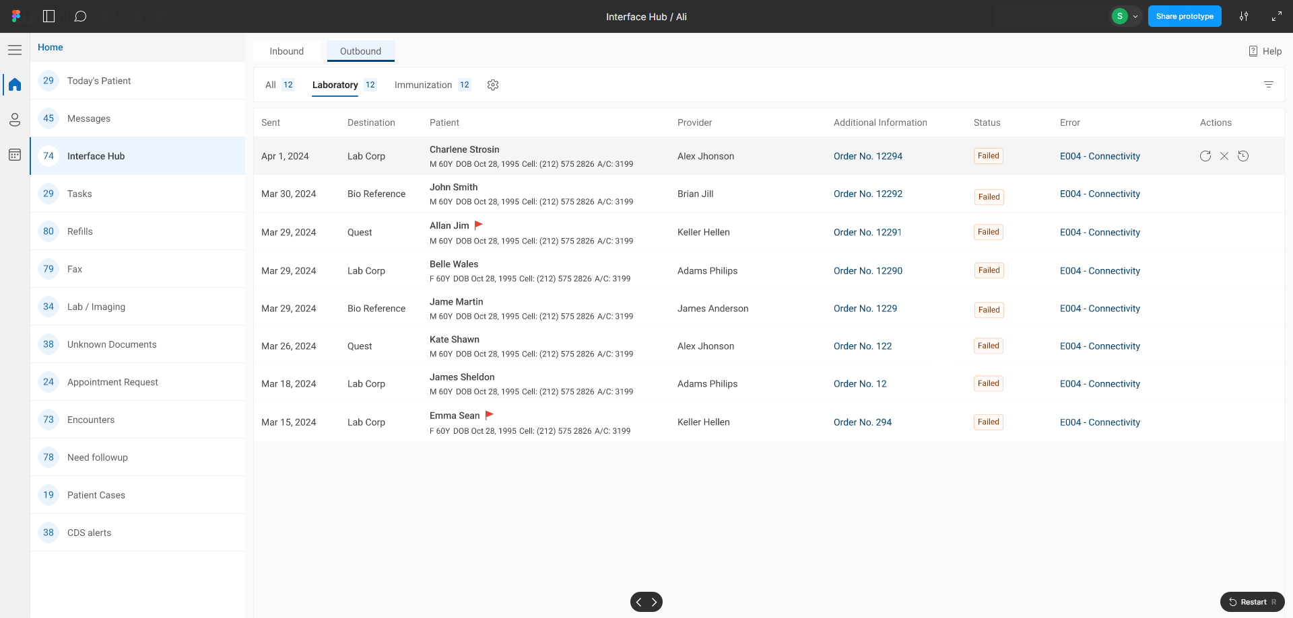

## 3.2 Categories

* System will track all messages of the following components:
  + Laboratory
  + Radiology
  + Immunization
  + Demographics
  + Appointments
  + Superbill
  + Clinical Notes
  + Documents
* Upon hovering on the ‘Settings’ icon the system shall display ‘Add Category’ in the tool tip. Clicking on the ‘Add Category’ icon will open a dropdown. User will be able to add or remove the tab of the component. 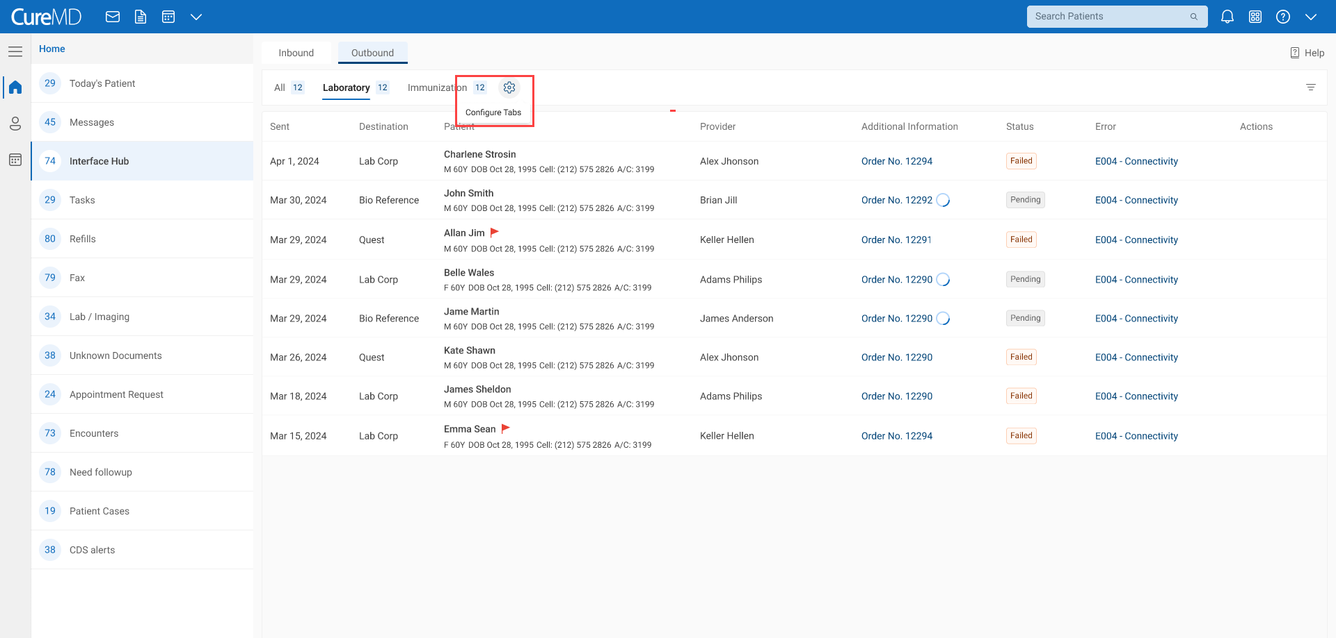
* System shall allow the user to drag and drop the tabs position within the drop down. System shall display minimum two tabs upfront.

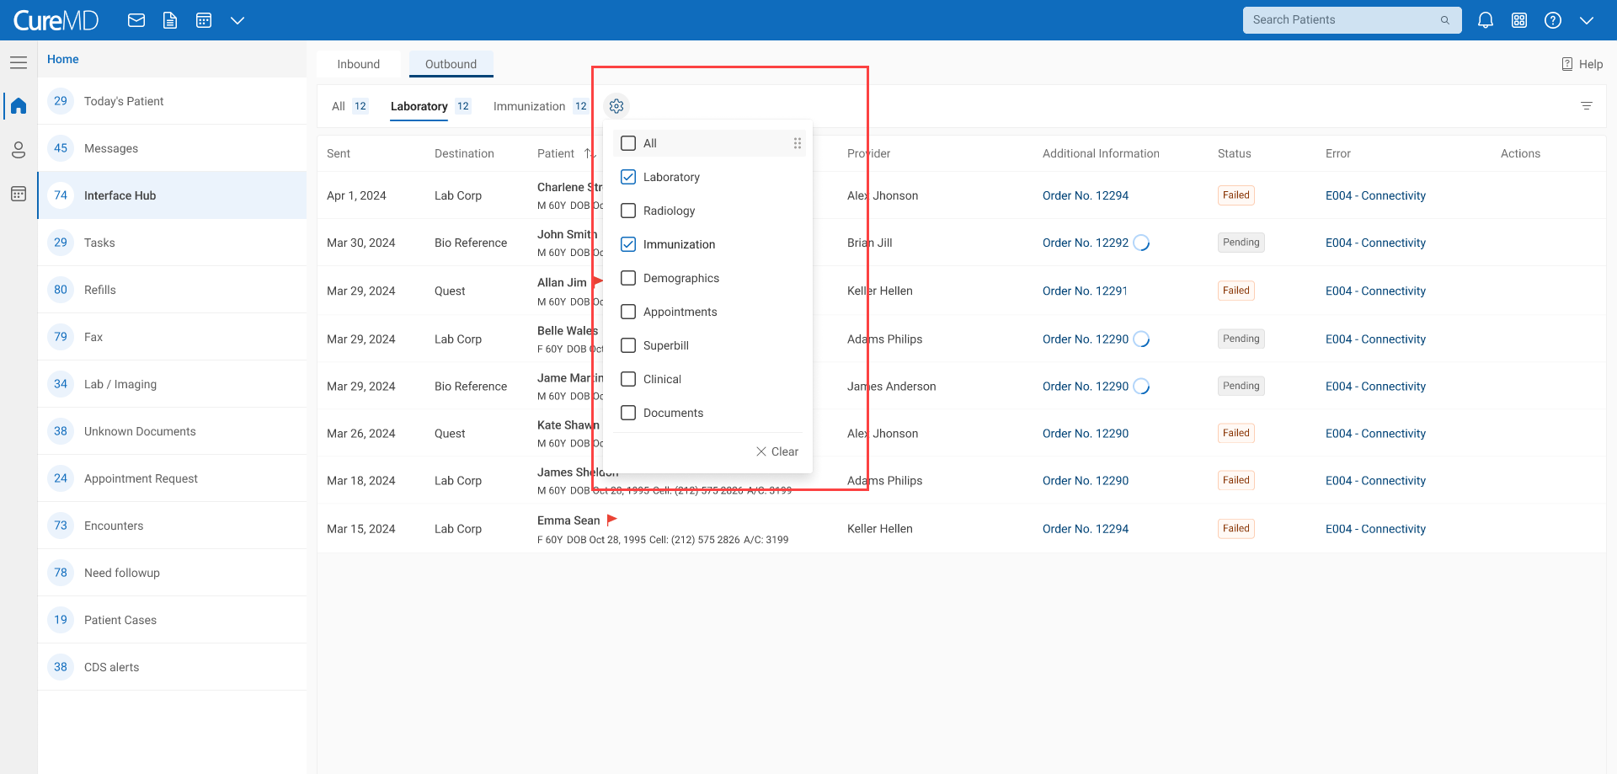

## 3.3 Filter and Search Messages

* **Filter:** User are able to search / filter the messages via ‘Filter’ icon and search box.

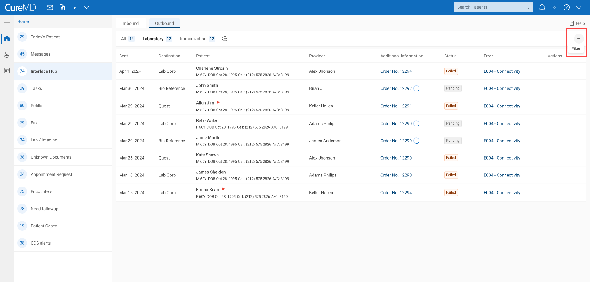

* + Clicking on icon will expand the search and filter options.

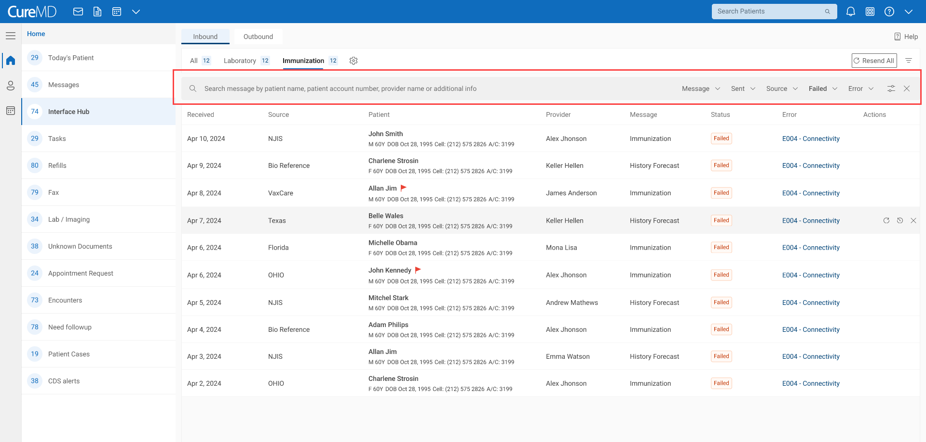

* + System shall allow users to filter messages on the basis of
    - **Sent/Received** : Date Range

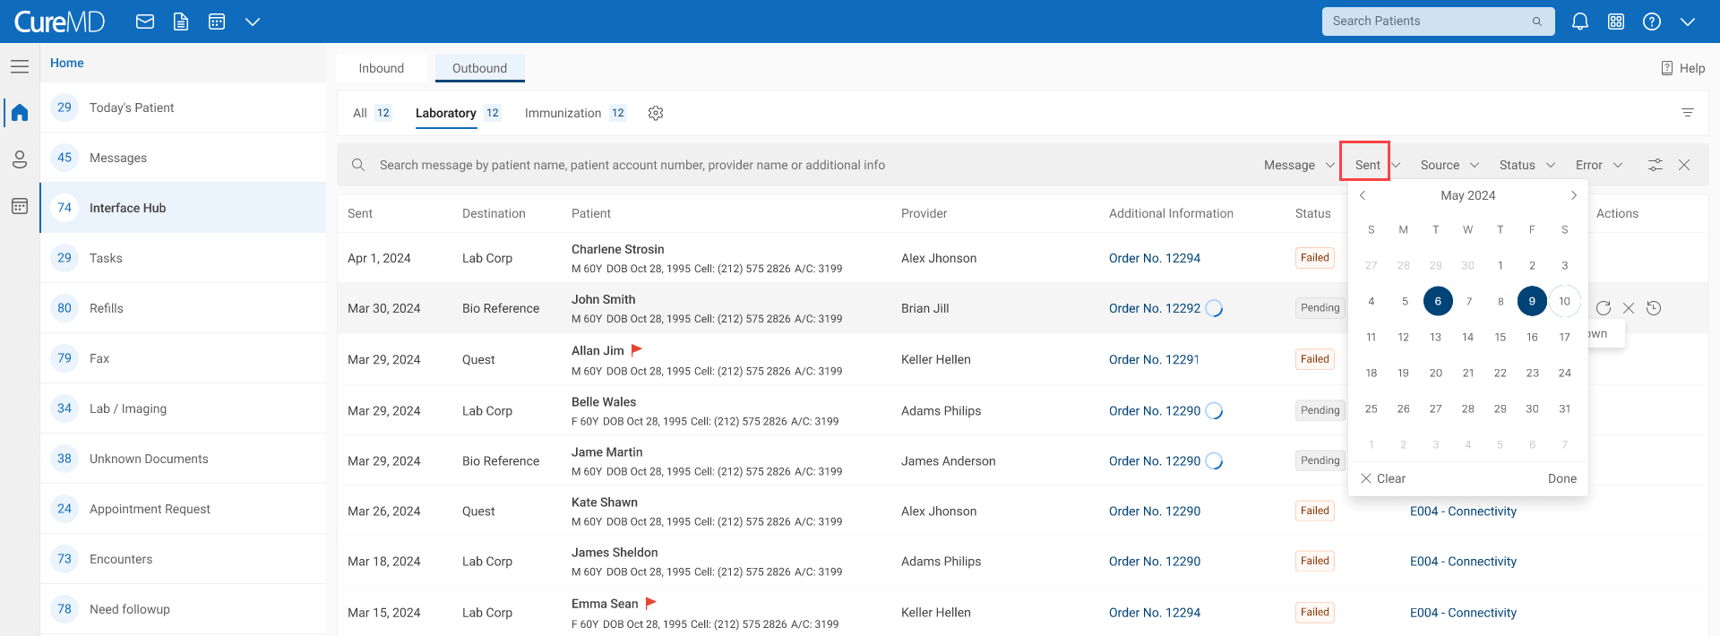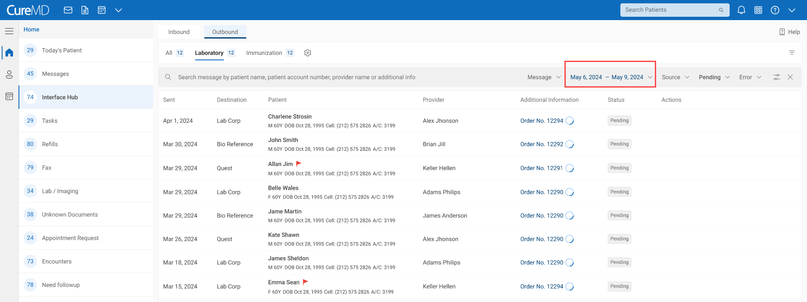

* + - **Source/Destination**: Multiselect dropdown
      * It will display all partners



* + - **Message**: Multiselect dropdown
      * It will have list of all message of the component

|  |  |  |  |
| --- | --- | --- | --- |
| Direction | Tabs (Component) | Message | Additional Info |
| Inbound | Clinical Notes | Clinical Notes | Provider Notes |
| Outbound | Clinical Notes | Clinical Notes | Provider Notes |
| Inbound | Superbill | Superbill |  |
| Outbound | Superbill | Superbill |  |
| Inbound | Immunization | History and Forecast |  |
| Outbound | Immunization | Immunization |  |
| Outbound | Laboratory | Lab Order | Order no |
| Inbound | Laboratory | Lab Result | Order no | Accession No |
| Outbound | Laboratory | Lab Result | Order no | Accession No |
| Inbound | Appointment | Appointment | Appointment Date and Time |
| Outbound | Appointments | Appointments | Appointment Date and Time |
| Inbound | Demographics | Demographics |  |
| Outbound | Demographics | Demographics |  |
| Outbound | Radiology | Radiology Order | Order no |
| Inbound | Radiology | Radiology Results | Order no | Accession No |
| Outbound | Radiology | Radiology Results | Order no | Accession No |
| Inbound | Document | Document | Destination: Document Manager “Folder Name > Document name and date |

**Note:** We will include other message type such as FHIR and APIs etc. in the future.

* + - **Status**: Multiselect dropdown
      * All, Pending, Failed, Rejected and Sent
      * By default, ‘Failed’ status is selected.
    - **Error:** Multiselect dropdown.
      * List of all error such as E001 – Connectivity



* + Moreover, the filters icon allow user to add or remove more filters. Applied filter will appear upon selection.
    - **Location:** Multiselect

This is the location where the patient is registered.

* + - **Ordering Location:** Multiselect

**Dev’s Comment**

The *Ordering Location* refers to the location from which an order is placed. For example, if a practice operates from two locations, 'Location A' and 'Location B,' and a patient is registered at 'Location A,' but the order is placed from 'Location B,' you can use these features as follows:

* Location Dropdown: Use this to filter records for patients registered at 'Location A.'
* Ordering Location Dropdown: Use this to filter orders placed from 'Location B.'

This allows you to differentiate between where the patient is registered and where the order was actually placed, giving you more precise control over your records. Can we add all for both locations?

* System shall retain filters based on user selection

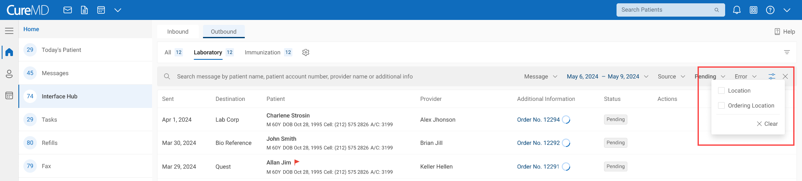

* **Search:** Users can use keyword search to find message by using the following information
  + Patient Name
  + Patient account Number
  + Provider Name
  + Additional info

**Note:** When searching for a message, a list of results matching the keywords will appear. The matched portion will be shown in regular font, while the remaining text will be in bold (just like google).

* The system shall display the three most recent searches in search list.

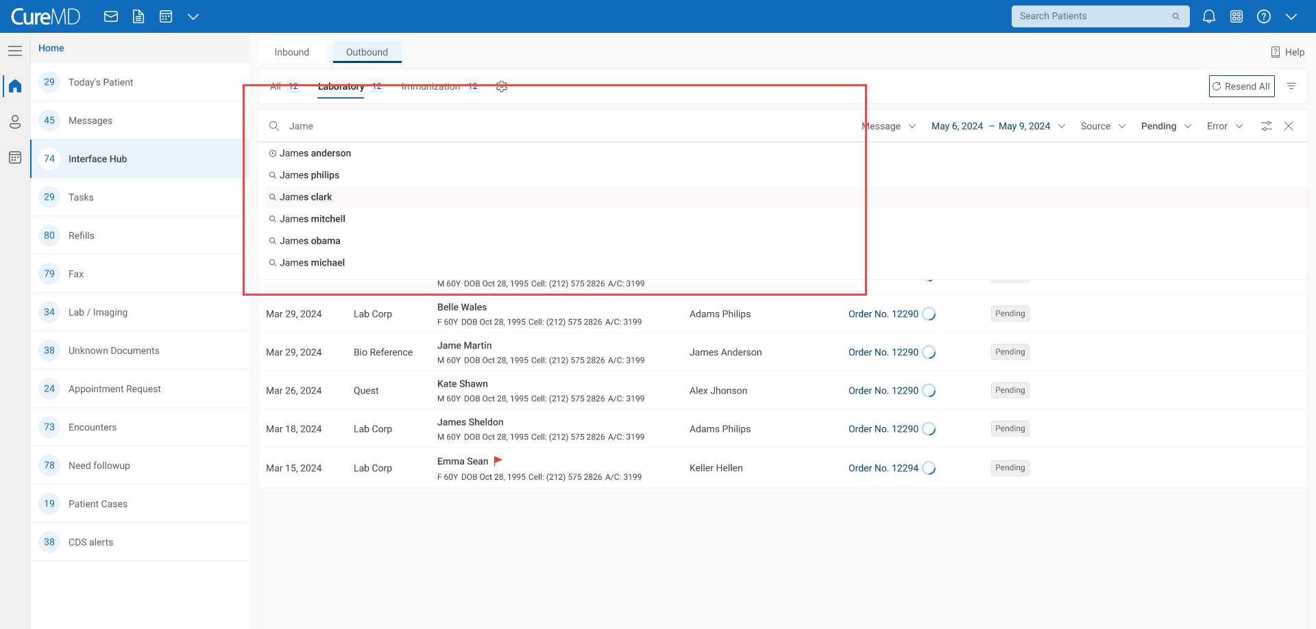

* **Message Listing:** System shall display the following details for each message:
* Received On: Message received Date (Inbound)
* Created On: Message received Date (Outbound)
* Source: The partner from where message is received (Inbound)
* Destination: The partner to who message was send (Outbound)
* Patient information
  + Patient first name
  + Patient last name
  + Gender
  + Age
  + DOB
  + Account Number
* Provider
  + Provider first name
  + Provider last name
* Message
* Additional Info

|  |  |  |  |
| --- | --- | --- | --- |
| Direction | Tabs (Component) | Message | Additional Info |
| Inbound | Clinical | Clinical | Provider Notes |
| Outbound | Clinical | Clinical | Provider Notes |
| Inbound | Superbill | Superbill |  |
| Outbound | Superbill | Superbill |  |
| Inbound | Immunization | History and Forecast |  |
| Outbound | Immunization | Immunization |  |
| Outbound | Laboratory | Lab Order | Order no |
| Inbound | Laboratory | Lab Result | Order no | Accession No |
| Outbound | Laboratory | Lab Result | Order no | Accession No |
| Inbound | Appointment | Appointment | Appointment Date and Time |
| Outbound | Appointments | Appointments | Appointment Date and Time |
| Inbound | Demographics | Demographics |  |
| Outbound | Demographics | Demographics |  |
| Outbound | Radiology | Radiology Order | Order no |
| Inbound | Radiology | Radiology Results | Order no | Accession No |
| Outbound | Radiology | Radiology Results | Order no | Accession No |
| Inbound | Document | Document | Destination: Document Manager “Folder Name > Document name and date |

* Status (Further explained in section **3.5 Actions on Messages**)
  + Pending
  + Failed
  + Rejected
  + Sent
* Error type

All categories with their error codes will be displayed (See section **3.7 Error Detection and Handling**)

3.4 Sorting

System shall allow user to sort following columns

* + Received/sent date (most recent to oldest)
  + Source/Destination (alphabetical A-Z or Z-A)
  + Patient Name (alphabetical A-Z or Z-A)
  + Provider (alphabetical A-Z or Z-A)

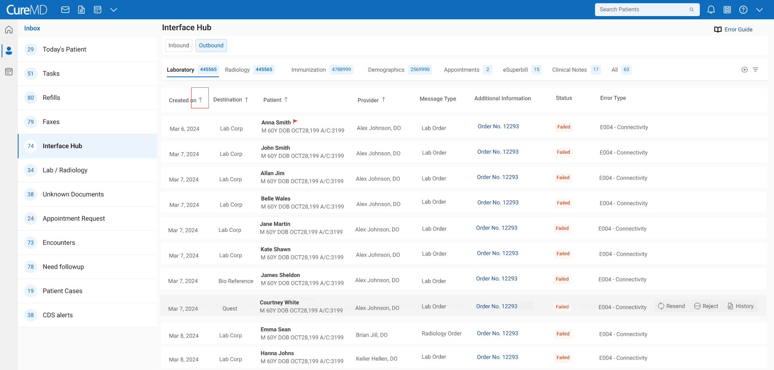

## 3.5 Actions on Messages

System shall display the actions that can be performed on each message upon hovering on the message. Following actions can be performed on each status based on the status.

**Queued**

* Option to view all the messages in the queue, upon hovering on the ‘Queued’ status, system should display the pending processing time in a tooltip.

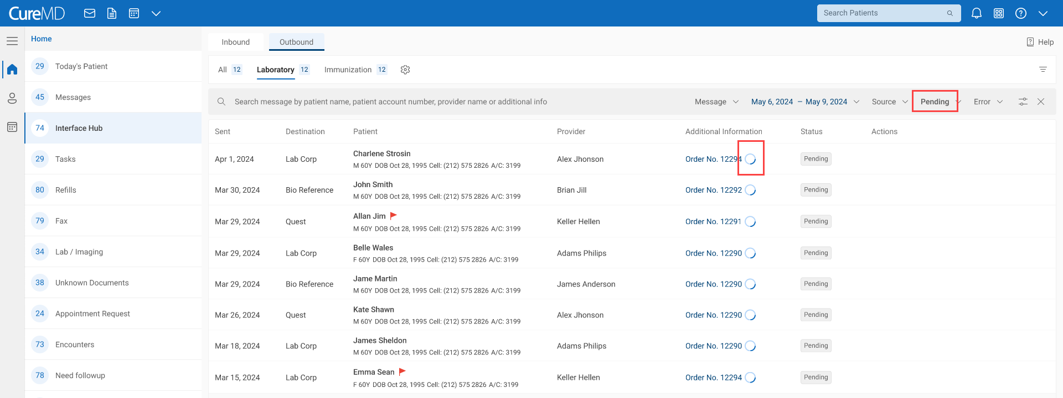

* + - Option to ‘Reject’ the message, Upon clicking users can add rejection reason.

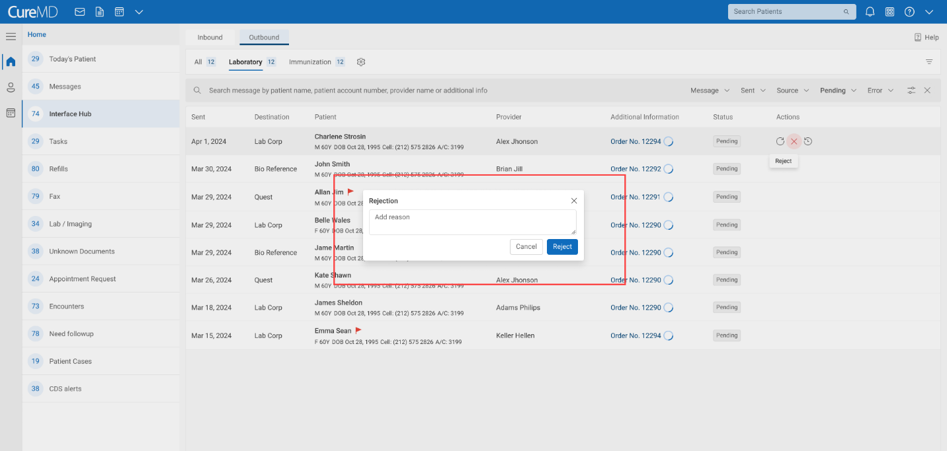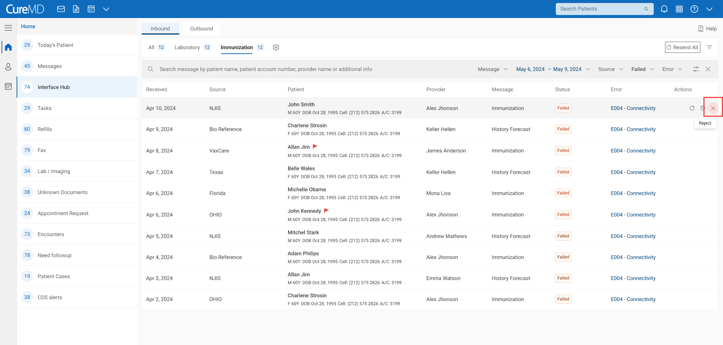

**Failed**

* + - Option to ‘Resend’
      * Individual Message: Upon hovering on the message system shall display the option to ‘Resend’ that message to the partner.

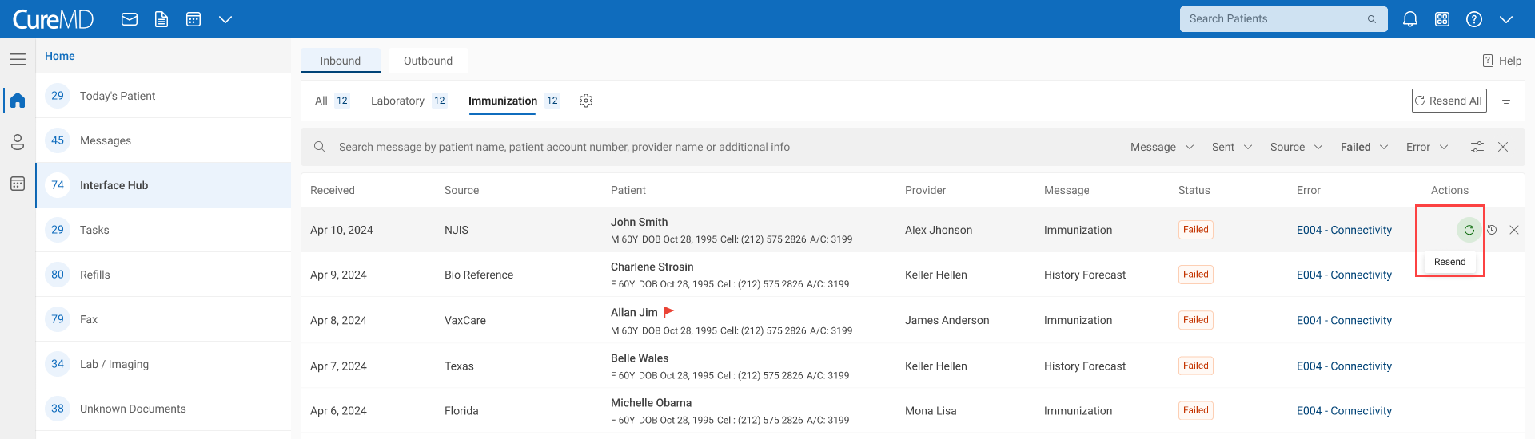

* + - * Bulk Messages: User will be able to click on ‘Resend All’ button to send all failed messages to the concerned partners.

'Resend All' is necessary when a third-party system has been down for more than 2-3 hours, and we need to reprocess the failed messages. Therefore, 'Resend All' will only be available when the user searches for records with a 'Failed' status within the last 30 days.

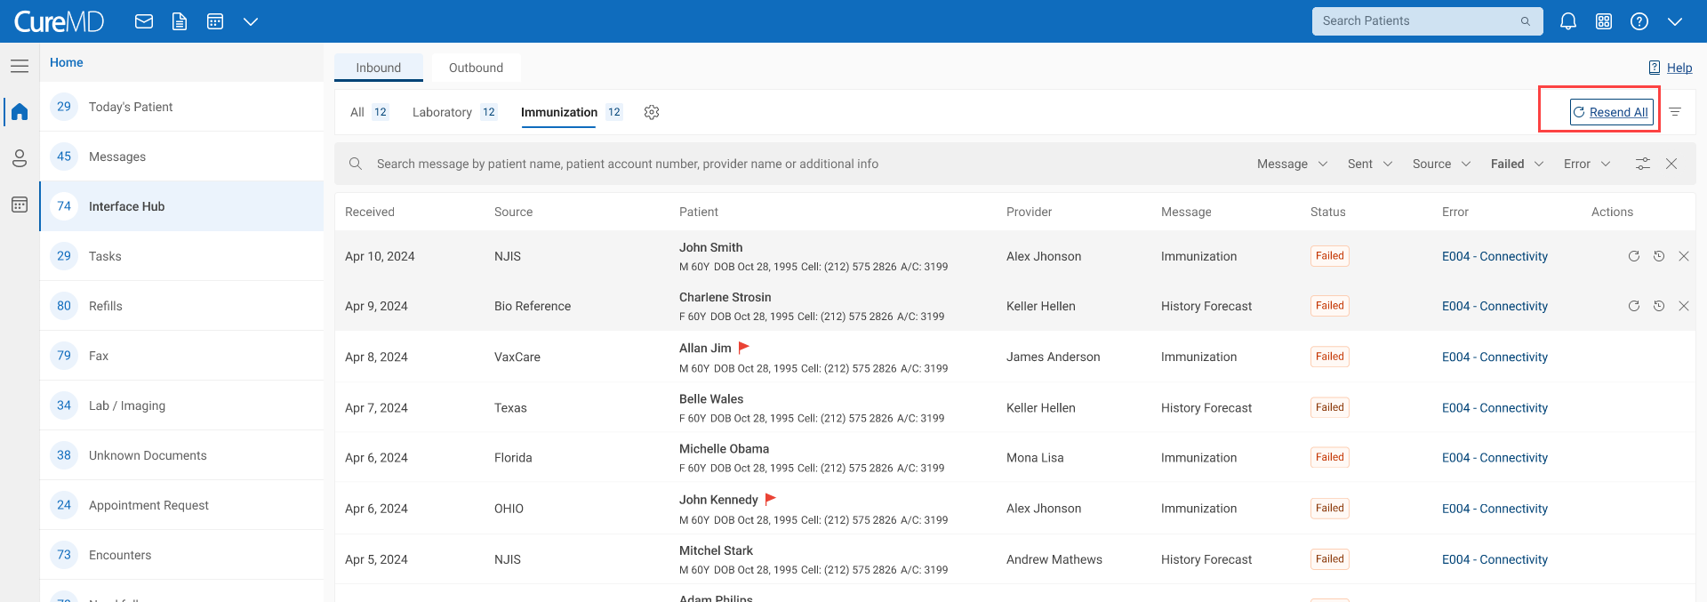

* + - Option to ‘Reject’ the message. Upon clicking uses can add rejection reason.

**Rejected**

* + - User will be able to view all rejected message and their rejection reasons.

**Sent**

* + - Option to ‘Resend’ again
      * For all sent messages, a blue dot icon will appear. Upon hovering user will be able to know the number of times an attempt is made to send the message before it is successfully sent.

System shall display the dot only for messages with multiple send attempts, not for all messages.

Don’t say attempts. if last sent was unsuccessful show in RED dot.

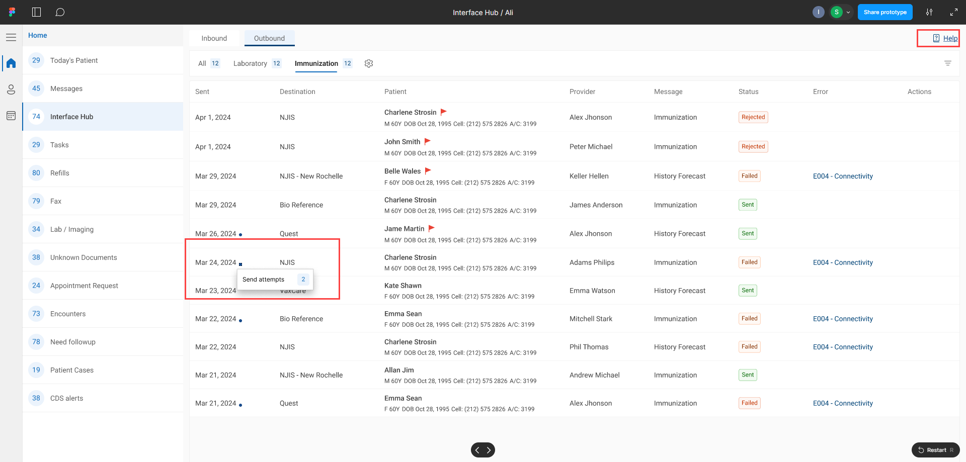

## 3.6 History

* Upon clicking history icon, system shall open message transaction history in the right pane.

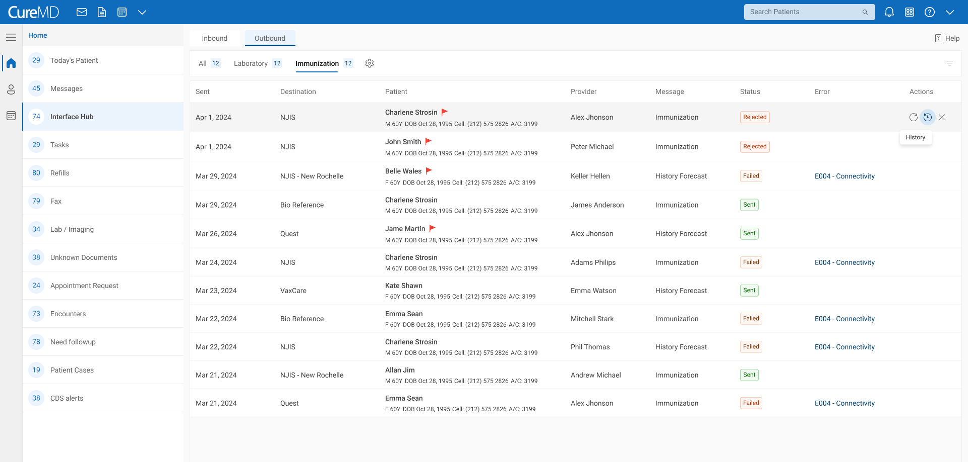

* The following format will be observed for the history

|  |  |  |  |
| --- | --- | --- | --- |
| **Direction** | **Message Transmission Status** | **Reason** | **HL7 File Generated** |
| InBound | Reprocessed | The particular HL7 message was processed again. | Yes |
| InBound | Patient Mapped | The message was received and was manually mapped to a particular patient by the user. | Yes |
| InBound | Received | HL7 message was received by our system | Yes |
| InBound | Processed | The HL7 message was processed by our system | Yes |
| InBound | Rejected | The message was rejected due to Manual or Electronic insertion of result/Financial Trans | Yes |
| OutBound | Downloaded | The created HL7 message file was downloaded | Yes |
| OutBound | Submitted | The created HL7 file was sent to the 3rd party | Yes |
| OutBound | HL7 Created | The system created an HL7 file according to specifications | Yes |
| OutBound | Rejected | The message was rejected by 3rd party, this could be due to multiple reasons. | No |
| OutBound | Submission Failed | The created HL7 file was not sent to the 3rd party | Yes |

**Format:**

<<HL7 Message Status>>

<<User Name who performed the action>> <<Date & Time on which the action is performed>>

In case of error, system shall display error information also such as

<<Error Code:>> <<Error Category>>

<<Error Description>>

<<User message>>

**Note:** The text color of ‘Error description’ will be in accordance with the severity color.

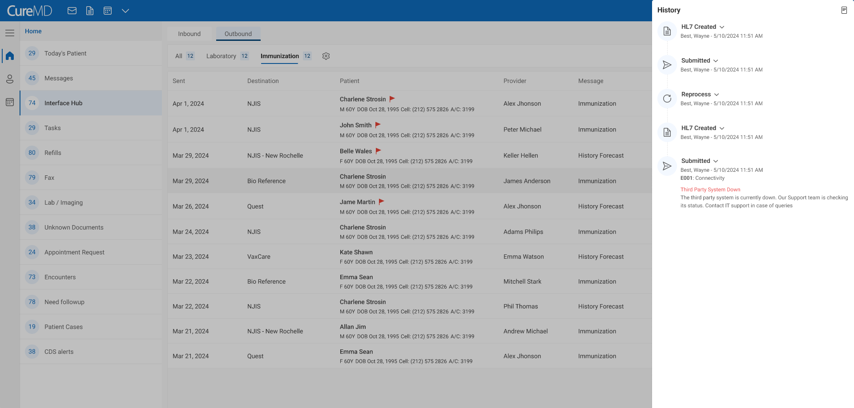

* Upon clicking status dropdown, the system shall give user the option to
  + **Download:** the HL7 message file in.txt format
  + **Preview:** the HL7 message in text previewer

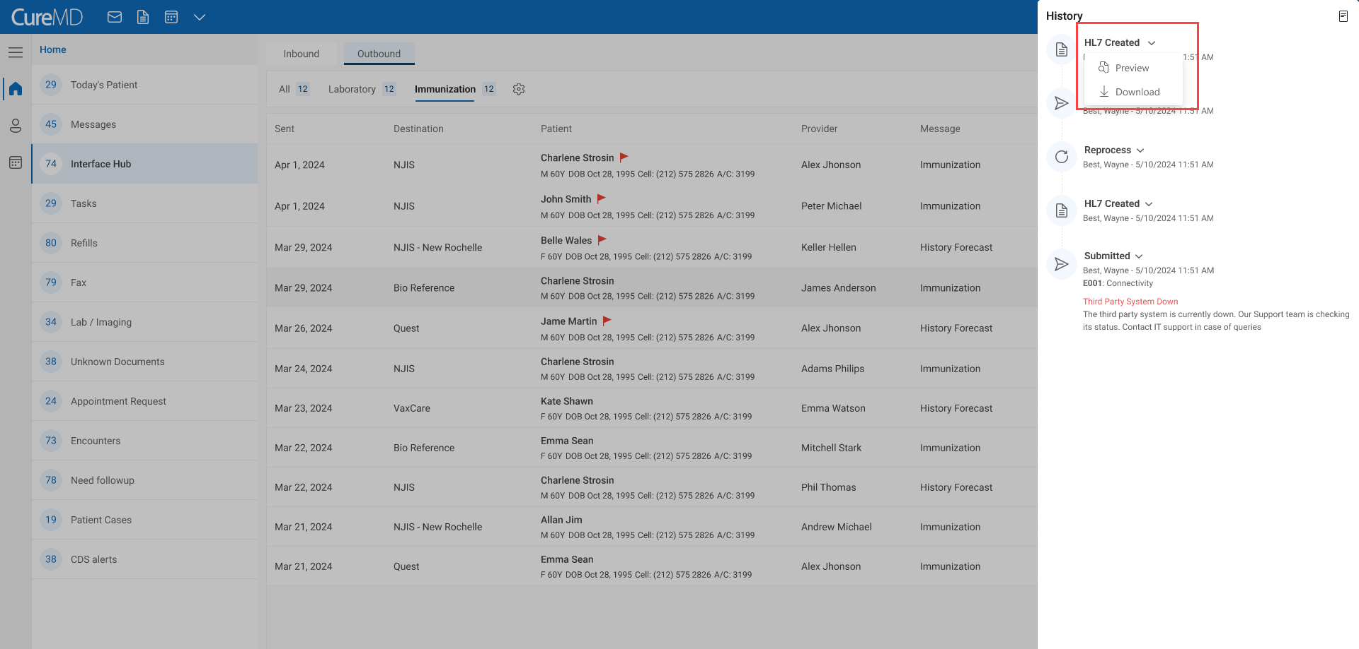

## 3.7 Error Detection and Handling

### Automated Error Detection

The system shall continuously monitor all inbound and outbound messages for errors. Common Error Types like connectivity issues, data format errors, missing required fields, mismatched patient information are to be fixed automatically

Once an interface is established between the CureMD application and a lab's system, labs typically do not accept notifications or messages via fax. Customization is essential because each lab specifies its own:

* Frequency for sending orders
* Retry limits for unsuccessful transmissions

To accommodate these varying requirements, CureMD provides flexible options in the Interface Configuration screen where you can set the retry limit based on the specific lab's needs and schedule the resend interval (in minutes) to control when CureMD should attempt to resend messages to the lab.

### 3.7.2 Error Identification and Categorization

* System shall be able to identify the error type and the following information for an error
  + Code
  + Type
  + Description
  + Severity
* Upon hovering on the Error Type, the system shall display the error details/description e.g.
  1. Error Type: **E201: Data Validation**

Tooltip: Mandatory Field Missing

* 1. Error Type: **E004: Connectivity**

Tooltip: Third-Party Server

* 1. Error Type: **E509: Server-Side**

Tooltip: Timeout



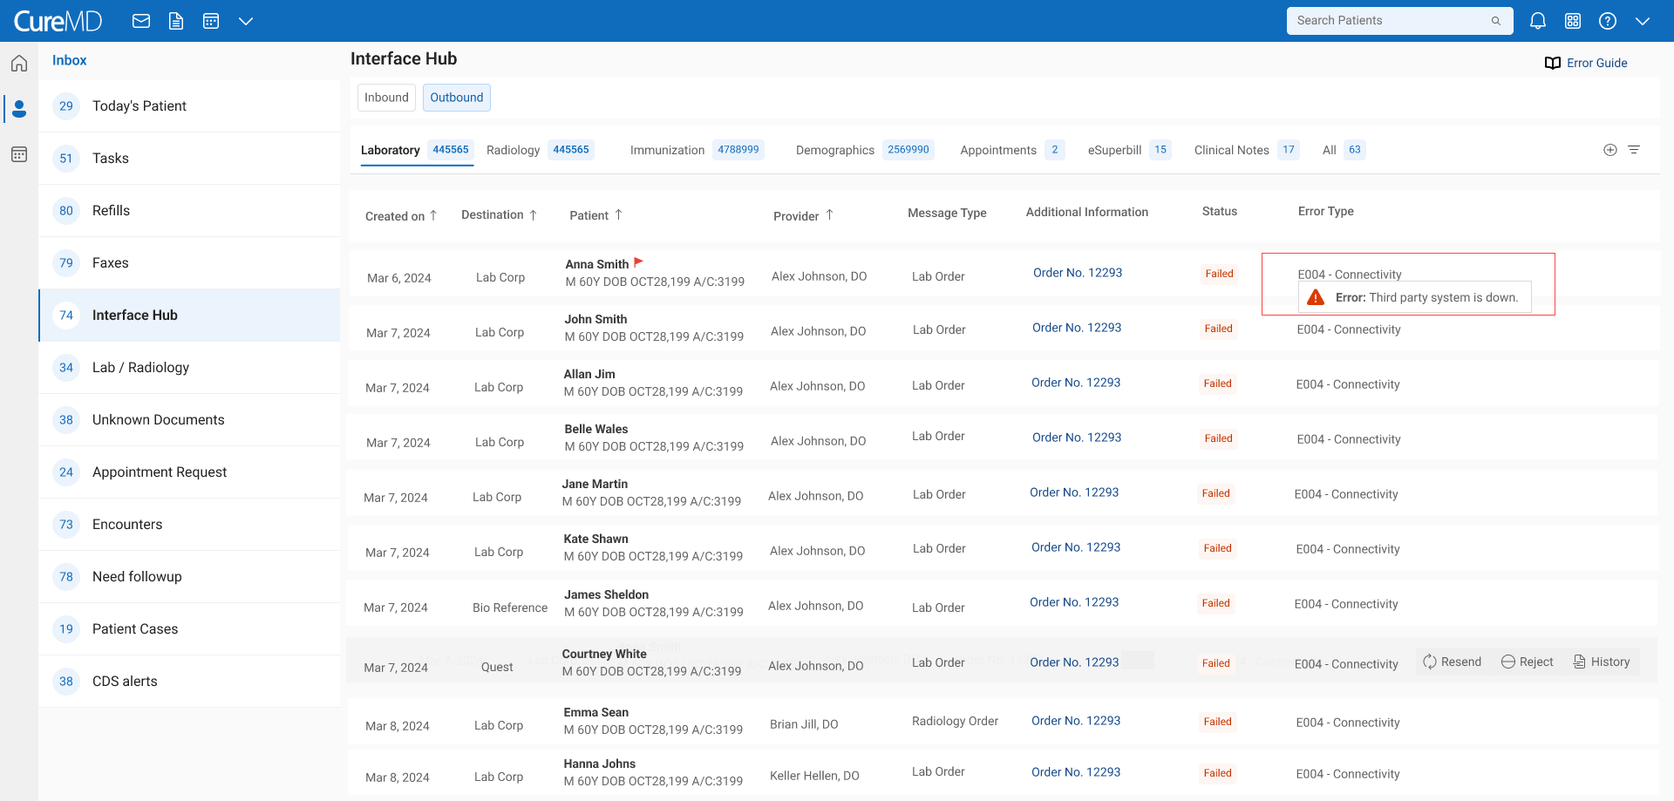

### Error Notification & Resolution

**Automated Correction:**

System shall implement self-healing capabilities that automatically correct common errors without human intervention e.g. correct data issue and resend message. The details are mentioned in the self-healing column of Error Guide sheet



**Retry Mechanisms:**

System shall automatically retry sending messages that failed due to transient issues, such as temporary connectivity problems.

**Configurable Retry Attempts for Transactions**

**Custom Retry Settings:** Retry attempts can be configured for each transaction in the system.

* + - Frequency for sending message
    - Retry limits for unsuccessful transmissions

**Example Scenario:**

If an interface is set to attempt sending a message three times with a 15-minute interval after a failure, the system will automatically follow this configured schedule. This flexibility ensures that the system adapts to specific needs, providing control over how and when retries are executed.

**Real-Time Error Alert**

System shall trigger immediate notification when any error is detected to manually review and resolve the error

All errors that needs to be fixed by the team (CS, Dev, Third Part), following process will be implemented for their resolution

**Error Reporting - CRM and Tracking Dashboard Integration**

* 1. We will integrate the CRM system with our tracking dashboard to streamline the issue tracking process.
  2. For each failed message reason category, a ticket will be automatically created in the CRM system.
  3. CS team will review the ticket and log a Devops ticket if required input from Dev, following the same process as Live Issues.
  4. All Devops tickets will be included in the Daily Live Issue, ensuring that all stakeholders are kept informed and up to date on the status of each issue.
  5. Readers will be able to open the ticket directly from the email, allowing for quick access to details and actions.

**Automated Alerts / Notification**

In-system notifications to practice users for them to take actions such as Patient mapping, resending, rejecting, or viewing the history of failed messages. System shall send notification to users who have permission to receive messages from labs and radiology**.** (Settings > Lab > Lab Profile > Notify User > Add User)

**Notifications:**

These will be User-Specific notifications.

**Outbound Traffic Notifications:**

When an outbound action, such as a lab order fails to process (e.g., due to a connectivity issue), the system will notify the user who created the relevant data

Example: If 'User A' signs a lab order and it fails to send to the lab, 'User A' will receive a notification informing them that the order could not be submitted successfully.

**Inbound Traffic Notification:**

If the system can't connect to labs to receive results, the system allows us to designate a specific user to receive these notifications who have permissions. (Settings > Lab > Profile > Notify User> Add User / (Settings > Radiology > Profile > Notify User> Add User / Settings > HIE Partners > Profile)

Here is the list of notifications that will appear in the notification pane.

|  |  |  |  |
| --- | --- | --- | --- |
| **Error Type** | **Notification Title** | **Notification Description** | **Action with Notification** |
| Connectivity | [Error Type] - [Message Type] - [Partner Name]  **e.g.** Connectivity - Lab Order - LabCorp | Connectivity issue detected. We've opened a support ticket. If it's not resolved within 24 hours, please contact our support team. | Review Support Ticket **Note:** Clicking on it will open the ticket in CRM |
| Data Validation | [Error Type] - [Message Type] - [Partner Name] | Data validation failed. We've opened a support ticket to review the details. If it's not resolved within 72 hours, please contact our support team | Review Support Ticket |
| Invalid HL7 Message | [Error Type] - [Message Type] - [Partner Name] | The HL7 message is invalid or incomplete. We've opened a support ticket to review it. If it's not resolved within 72 hours, please contact our support team | Review Support Ticket |
| Server-Side | [Error Type] - [Message Type] - [Partner Name] | A server-side error occurred, possibly due to technical issues. We've opened a support ticket to review it. If it's not resolved within 48 hours, please contact our support team | Review Support Ticket |
| File Type Validation | [Error Type] - [Message Type] - [Partner Name] | The file format is incorrect. We’ve opened a support ticket to review it. If it’s not resolved within 48 hours, please reach out to our support team. | Review Support Ticket |
| Acknowledgment Handling | [Error Type] - [Message Type] - [Partner Name] | There was an issue with processing acknowledgments. We’ve opened a support ticket to verify message status. If it’s not resolved within 72 hours, please reach out to our support team. | Review Support Ticket |
| Unspecified | [Error Type] - [Message Type] - [Partner Name] | An unexpected error occurred. We've opened a support ticket to investigate the issue. If it's not resolved within 72 hours, please contact our support team | Review Support Ticket |

All notifications will be displayed in the notification pane, under the Interface Hub Heading.

User will be able to click on the review icon to open the CRM support ticket in a new window.

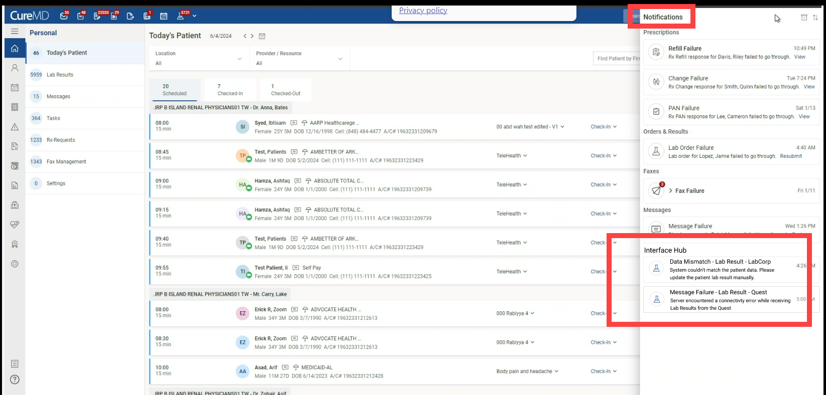

### 3.7.4 Error Guide

System shall display a ‘Help’ icon to view the error guide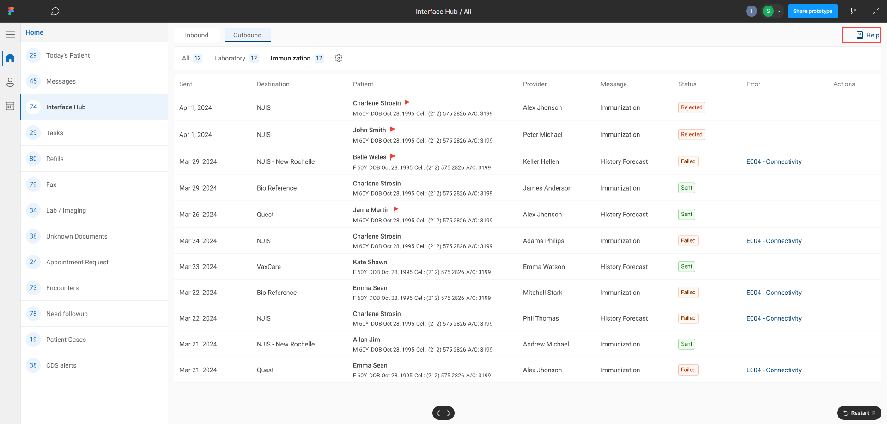

Clicking on help guide will open the ‘Help’ pop up. Here, the user will be able to read the error description to know what can be done for the error of specific type.



Here, the user will be able to see the solution advised to resolve each error. Along with the following information

* + Code
  + Type
  + Severity
  + Interpretation
  + Description

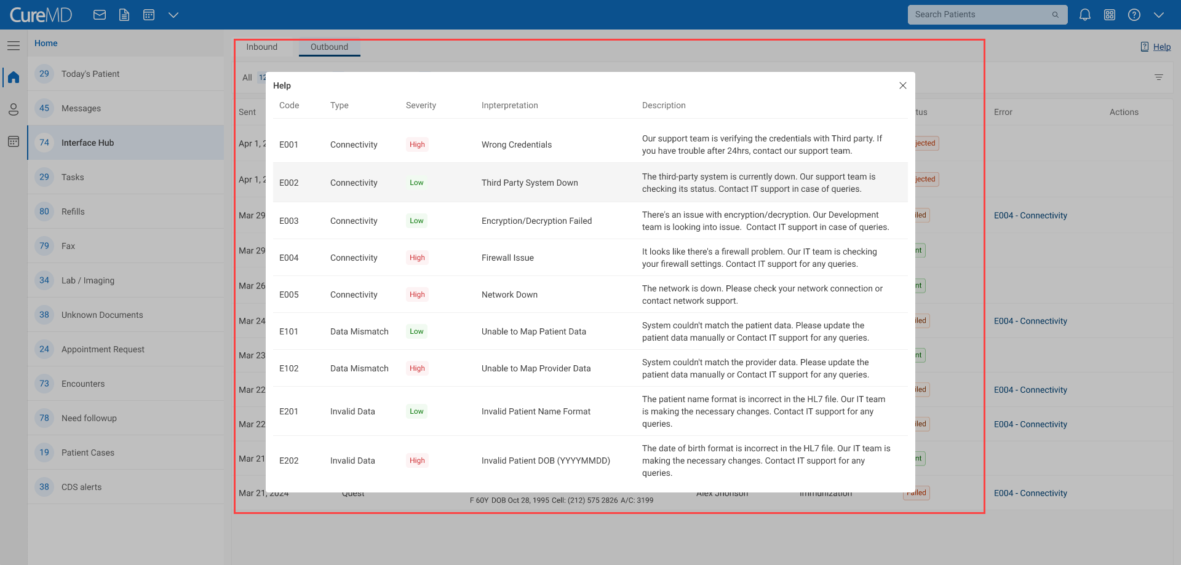

## 3.7.5 Data Mismatch

[Need to finalize if we want to treat Data Mismatch as Error and allow user to map from tracking as well. Please check Matt’s feedback at the end and suggest]

* For the Incoming lab and radiology results , if the result does not match with existing patient or provider name, an error 'Data Mismatch' will appear.
* User will click on the 'Data Mismatch' to correctly map the result against the patient.

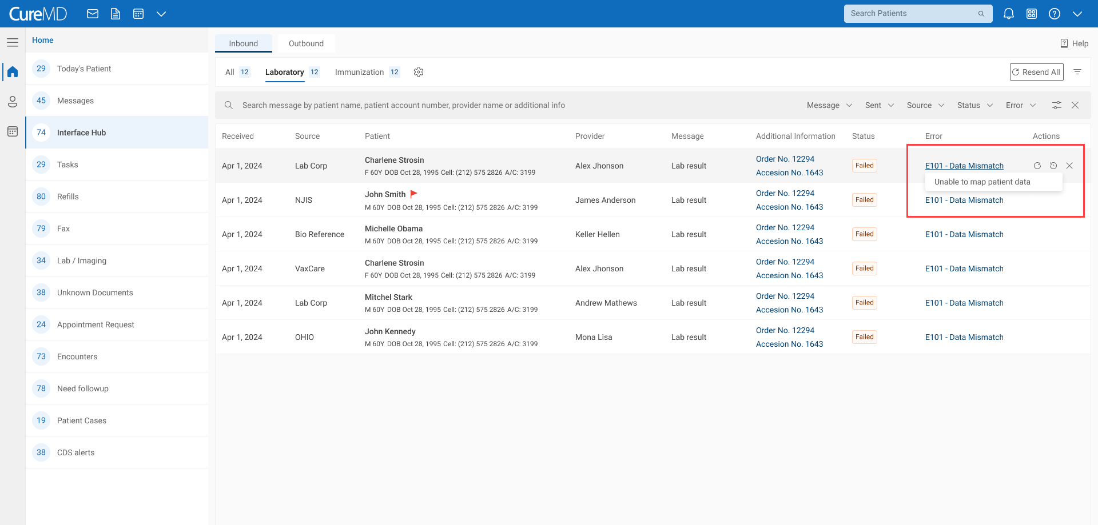

* Upon clicking on the hyperlink, the system shall open the ‘Map Patient’ pop up.
* System shall run the following matching algorithm to compare incoming lab result with available patient details and Lab order in the system. The detail includes:
  + - Patient Name
    - Gender
    - Date of Birth
    - Account Number
    - Match Lab/ Radiology Orders Details
* System will calculate a confidence score indicating the accuracy of data match against all the above fields and suggest the possible patient with lab results.
* System shall display incoming patient details in the header.

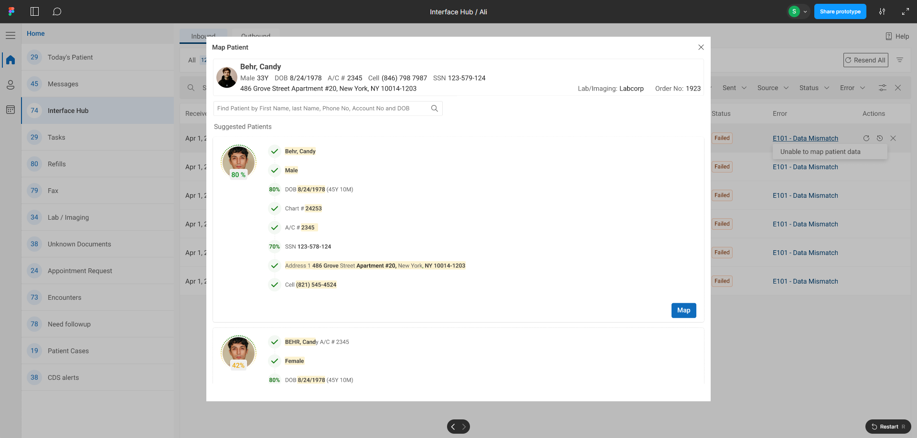

* System shall also display the order information is also displayed in the header
  + - Lab
    - Order No: Upon hovering on the order no, the system shall display the order details.

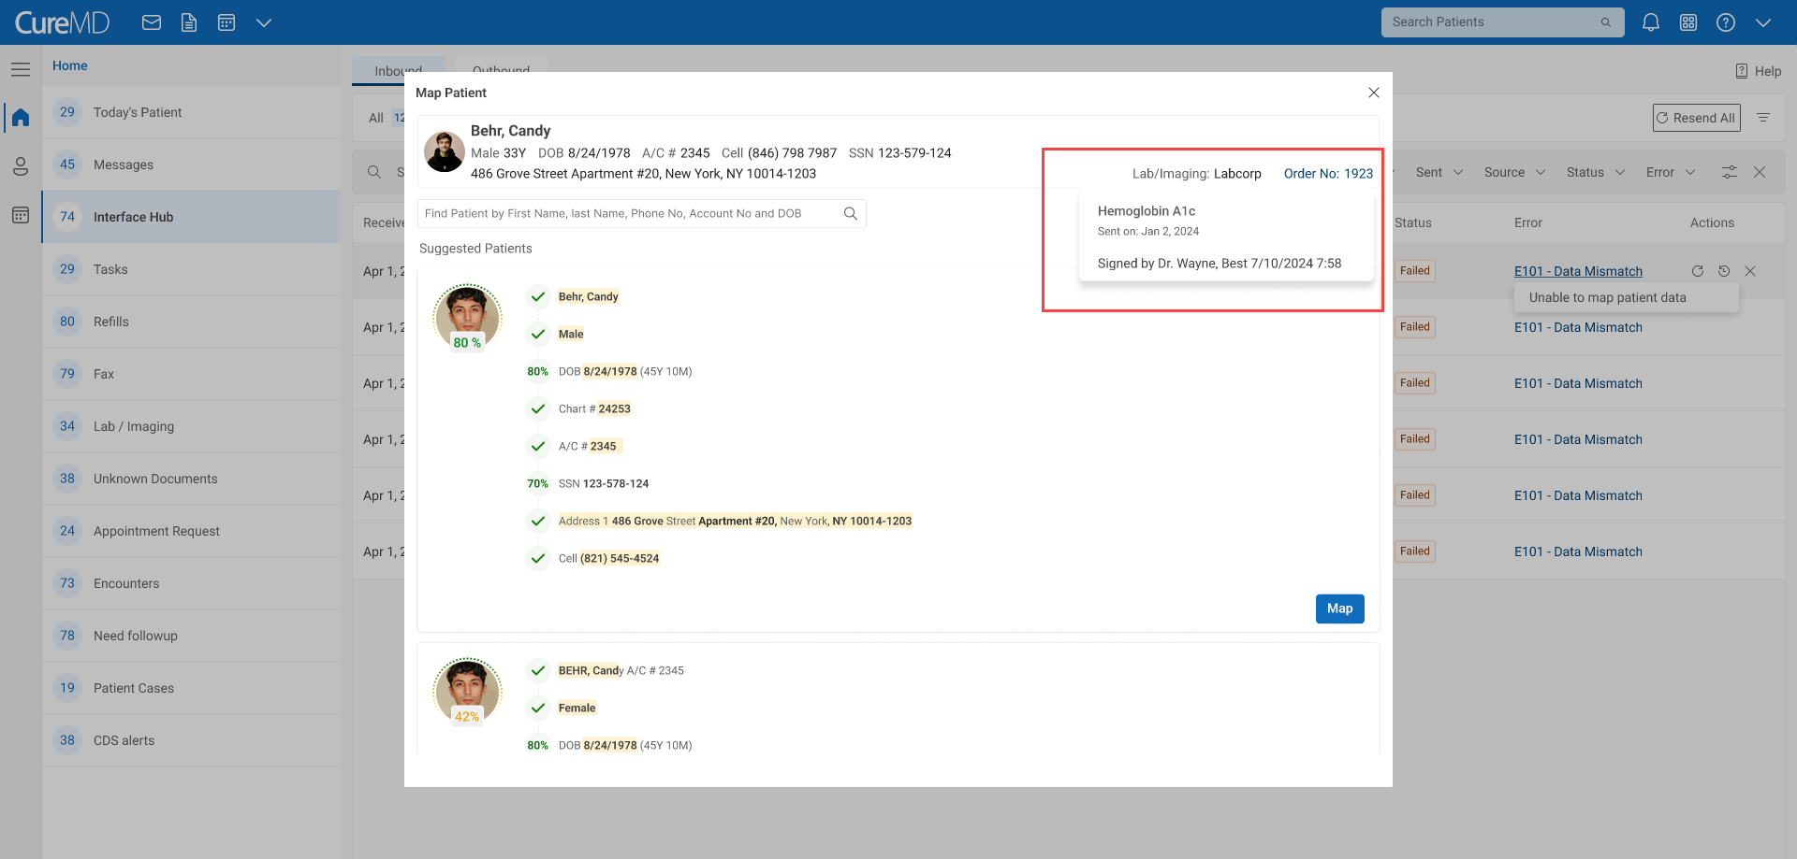

* Show "Map" button, allowing users to map patient manually to fix any mismatch or incomplete information.

## 3.7.6 Order and Results

Interface Hub Dashboard will be used to monitor message transmission and simplify auto correction of errors. This has been discussed with Ken, Nida and Abdul Majid, we are not manually submitting new order from here. Manual Orders will be sent through Today’s Patient > Clinical > Orders

* System shall allow user to view order and results from the interface hub dashboard.
* Clicking on the ‘Order no.’ hyperlink will open the order details.
* Clicking on the ‘Accession no.’ hyperlink will open the incoming results.

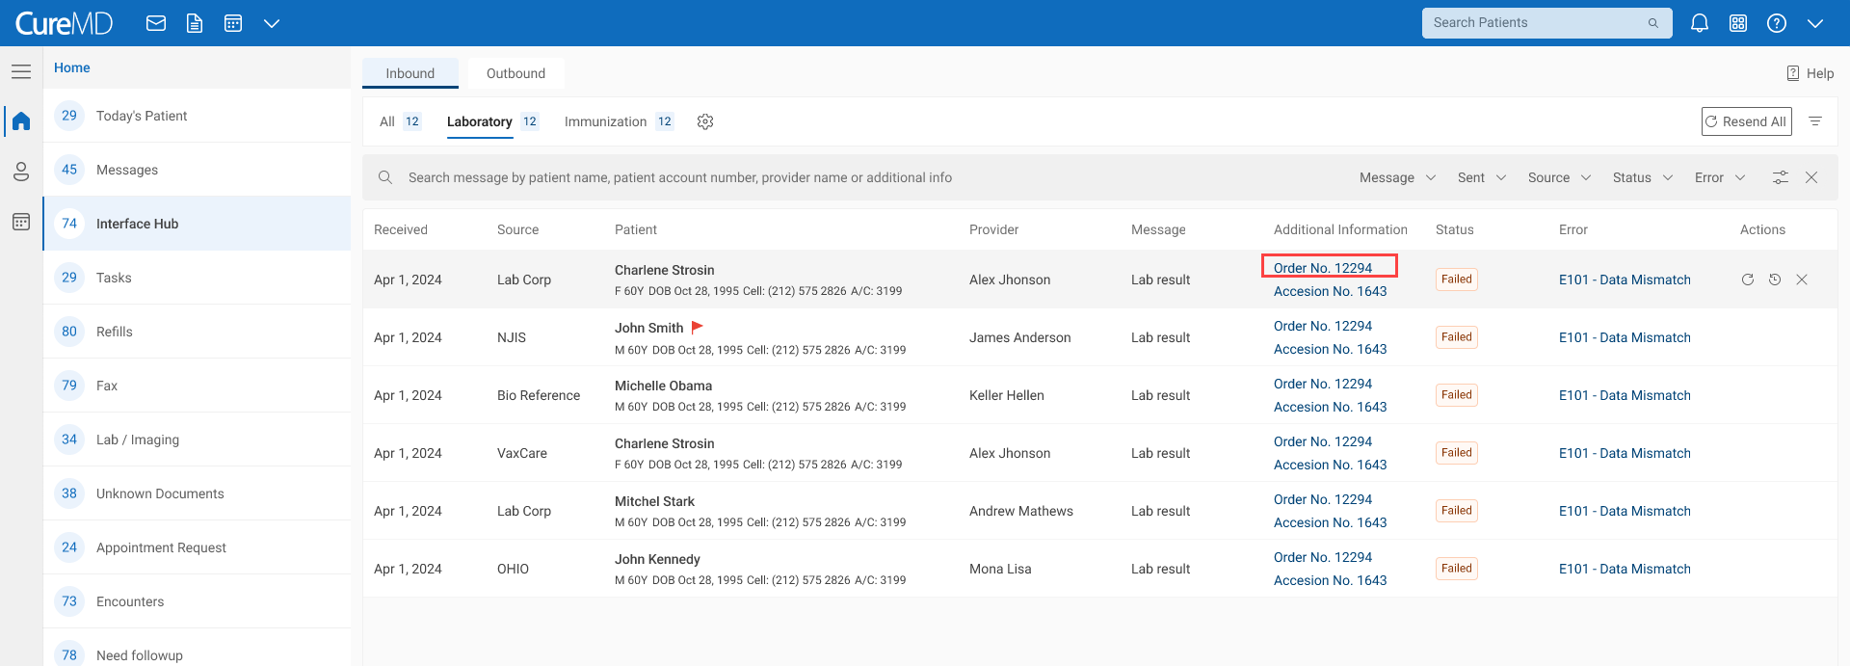

* Order Details:
  + Lab
  + Order No.
  + Patient details
    - Patient Name
    - Gender
    - Age
    - Date of Birth
    - Account Number
    - Cell Phone
    - Address
  + Ordering provider
  + Tests
    - Name
    - Order sent date
  + User Name who signed the order
  + Date & Time on which order is signed

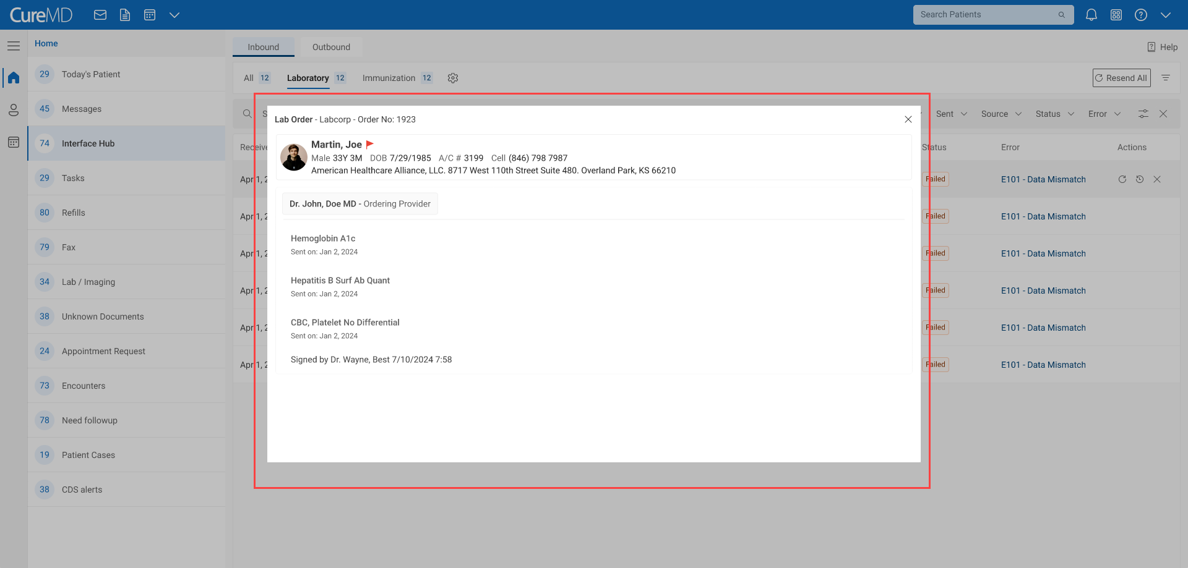

* Result Details: [Need to finalize if we want to show Lab Results from tracking. Please suggest]
  + Lab
  + Order No.
  + Accession No.
  + Patient details
    - Patient Name
    - Gender
    - Age
    - Date of Birth
    - Account Number
    - Cell Phone
    - Address
  + Result Status:
    - Completed: Result is acknowledged or reviewed by provider
    - Partial: Result against one of the tests is received
    - Final: Result is received for all Tests
    - Correction: Any change is done in results
  + Ordering provider
  + Order sent date
  + Lab reports attachments
  + Diagnosis
  + Tests
    - Observations
    - Ref Ranges
    - Result date
    - Four Most recent results (if exits)

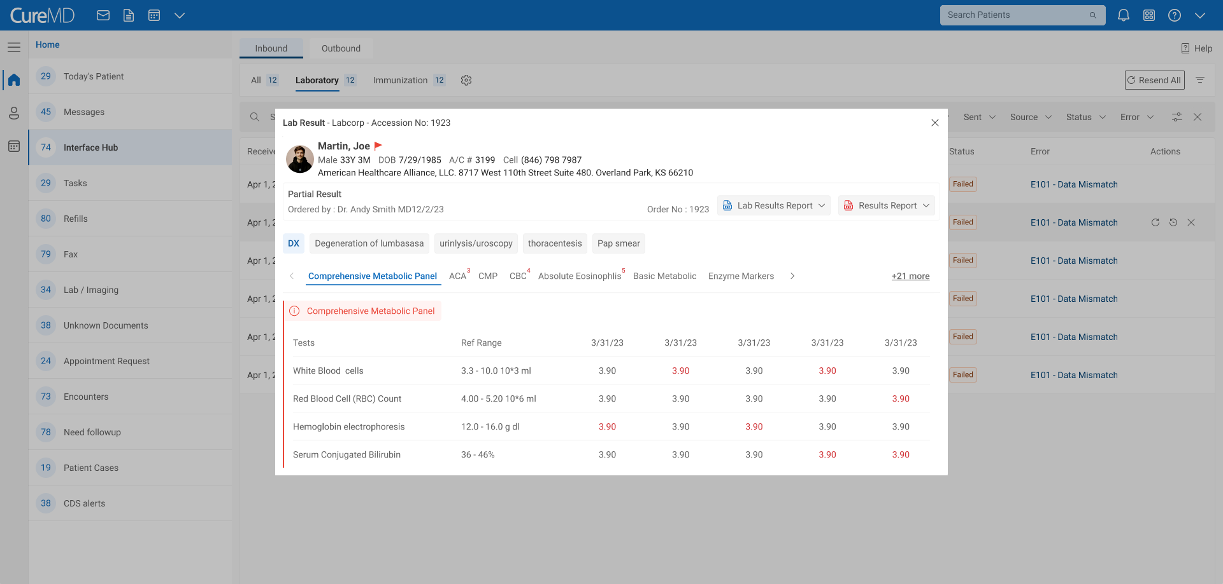

## 3.7.7 Message Archiving

* archive messages that are older than 1 month and have no issue. Archived messages will appear on the tracking dashboard but user <will not be able to perform any action on the message > . I don’t agree with this; please architect come up with a better method to be able to fix older m/ archived messages. How can we do that; please have him see me in person with you. [**Dev will discuss this in-person with BH**]
* User can see the message ‘History’ but will not be able to download the message files from here.

# 4 User Interface

Here is the figma link to prototype

<https://www.figma.com/proto/qDlM4clYmnroibHAU9deBR/Interface-Hub-%2F-Ali?page-id=0%3A1&node-id=1-6203&viewport=752%2C290%2C0.29&t=QD0RYCSd3vTHG6bG-1&scaling=min-zoom&content-scaling=fixed&starting-point-node-id=1%3A6203>

Here is the figma link to concept design

<https://www.figma.com/proto/bMNuKqsR3dP0uEQpWMco9H/Untitled?node-id=1794-28401&t=eNMVxqawlUMrGFTI-0&scaling=min-zoom&content-scaling=fixed&page-id=0%3A1&starting-point-node-id=1794%3A28401>

# 5 Feedbacks

Craig’s

**Split Lab/Radiology Tabs:** To address the high volume of messages in each module and to better manage user views, separate the lab and radiology tabs. This change will allow users to view the order numbers for each type without needing to apply filters.

**Ability to Drag and Drop Tabs:** We can implement filters to add tabs and potentially drag-and-drop functionality to reorder them.

**Permission-Based Notifications:** Notifications should be permission-based. In larger practices, specific users are designated to manage the tracking page or problem list, so notifications should be restricted to relevant users to avoid unnecessary alerts.

**Bulk Reprocessing:** Enable bulk reprocessing for messages that get stuck in problem lists, particularly when the vendor service is down. This is a common need.

**No Need of Note Section with Message:** There is no use case of having a note with incoming and outgoing message. The messages details on the dashboard are self-explanatory and do not require additional context.

**‘All’ Tab Not Required:** The ‘All’ Tab is intended to give a broad view of messages from all components in one place. However, displaying such a large volume of messages can be overwhelming for the user. Since users can already access these messages through their respective component tabs, removing the ‘All’ Tab would reduce redundancy and streamline the interface, making it more user-friendly.

**Remove** **Data Mismatch Issues from the Interface Hub Tracking**

Agreed to remove but practices who receive results from hospitals are huge in numbers, it may result in spam for them. We should remove this from tracking and show in lab result listing with additional filter like "problem list" or "mismatch result" etc. so they can view these results when they want to. By default, it shouldn’t be shown just like this.

**Rename Pending Status to ‘Queued’:**

The status should be Queued since this bucket will contain Messages that are to be automatically transmitted and are in queue.

**No Need to Show ‘Send Attempts’ with Sent Messages:**

No use case for showing sent attempts. As per current implementation, if for some reason, let’s say a cure link is down or hub, order falls in the outbound problem list and we reprocess when service is up. Auto reprocessing should work 100%.

Matt’s

**Data Mismatch Issues in Lab Results Listing:** Data Mismatch is not an error. Patient result matching for data mismatches should be handled within the Lab Results listing in the inbox, rather than through the tracking module. This error tracking module is designed to monitor and correct errors, not necessarily to serve as the primary interface for reviewing incoming lab results.

**No Need to View Lab Results:** Currently, there’s no need for a use case to view detailed results from the tracking module. Users primarily need to see if an order number exists, which is already shown in the Additional Info column of the Laboratory component.

**Remove Option to Manual Send Pending Orders:** This functionality should be removed from this error tracking module too. We should allow user to send pending orders manually from the Lab Order Listing Page. User should be able to view Queued Orders there too.

**Remove Queued Icon from the Tracking Listing:** Since we are only displaying queued orders here, there is no need to show the queue icon with each record.

**No Need of Note Section with Message:**There is no use case of having a note with incoming and outgoing message. The messages details on the dashboard are self-explanatory and do not require additional context.

**‘All’ Tab Not Required:**The ‘All’ Tab is intended to give a broad view of messages from all components in one place. However, displaying such a large volume of messages can be overwhelming for the user. Since users can already access these messages through their respective component tabs, removing the ‘All’ Tab would reduce redundancy and streamline the interface, making it more user-friendly.

Ken’s

**Application Status Integration:**

Integrate the Application Status indicator on specific pages and link it with Status.io. Replicate this on the Orders component, and Orders and Results listing pages.

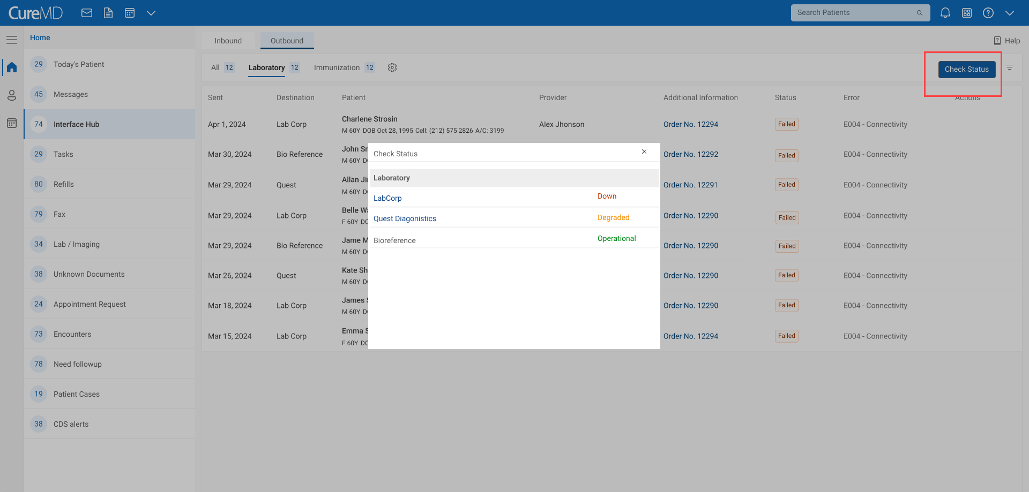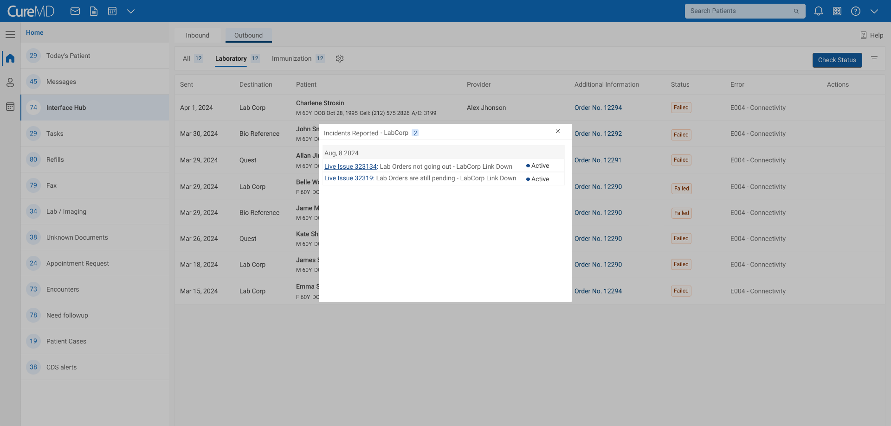

**Issue Status for Users:**

Issues handled by CureMD (Dev or CS Integration) should have a status that informs users that the issue is being worked on and identifies the responsible team.

**Universal Search Functionality:**

If no 'All' tab is included, implement a universal search feature, similar to the one in Today’s Patient.

**Mismatched Results Display:**

Agreed to show mismatched results within the results listing pages, similar to the implementation in Referrals, where Nimra has developed a prototype.

# 6 Approval and Sign-Off

The scope of the Interface Hub Dashboard project, as described in this document, is approved by the following stakeholders:

|  |  |  |  |
| --- | --- | --- | --- |
| **Name** | **Role** | **Signature** | **Date** |
| Bilal Hashmat | Chief Executive Officer (CEO) |  |  |